OS LAB 12

Name: shaheryar siddiqui ID: FA17-BECE-0023

Task1:
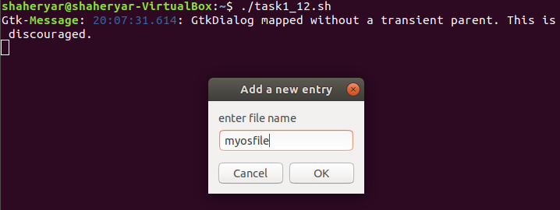
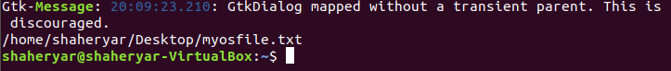
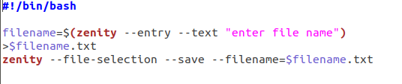

TASK2:

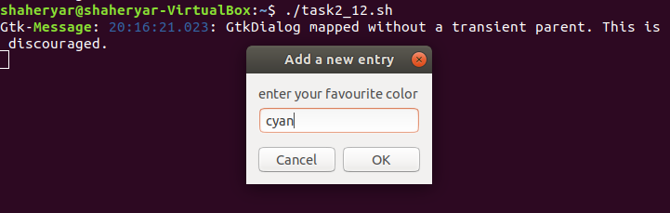
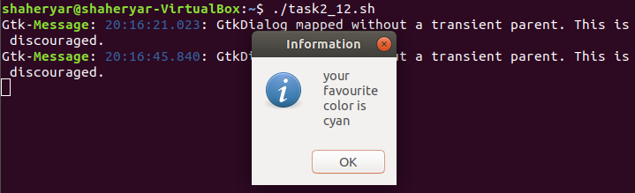
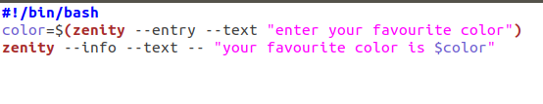
TASK3:

